**login and register session in core php**

**introduction**

login and register session

**create database name queries**

login

CREATE DATABASE login;

**table name queries**

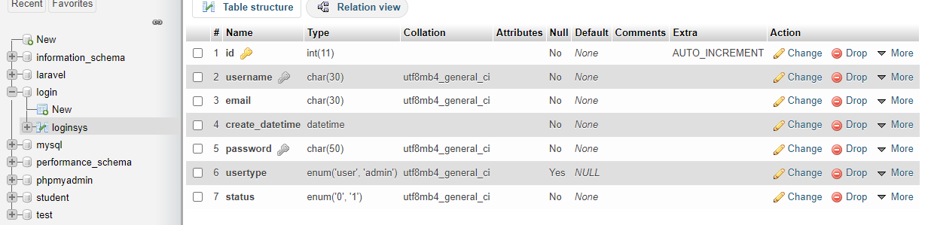

**Login.php**

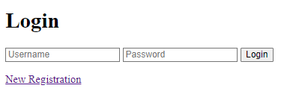

**Register.php**



**New added**







